Lab 07 – Worksheet

Name: Maleeha Prabha | ID: 09991  10292 | Section: T1

Note: Assumptions and logics should be explained separately in tasks after the task results.

Task 1
Block Diagrams
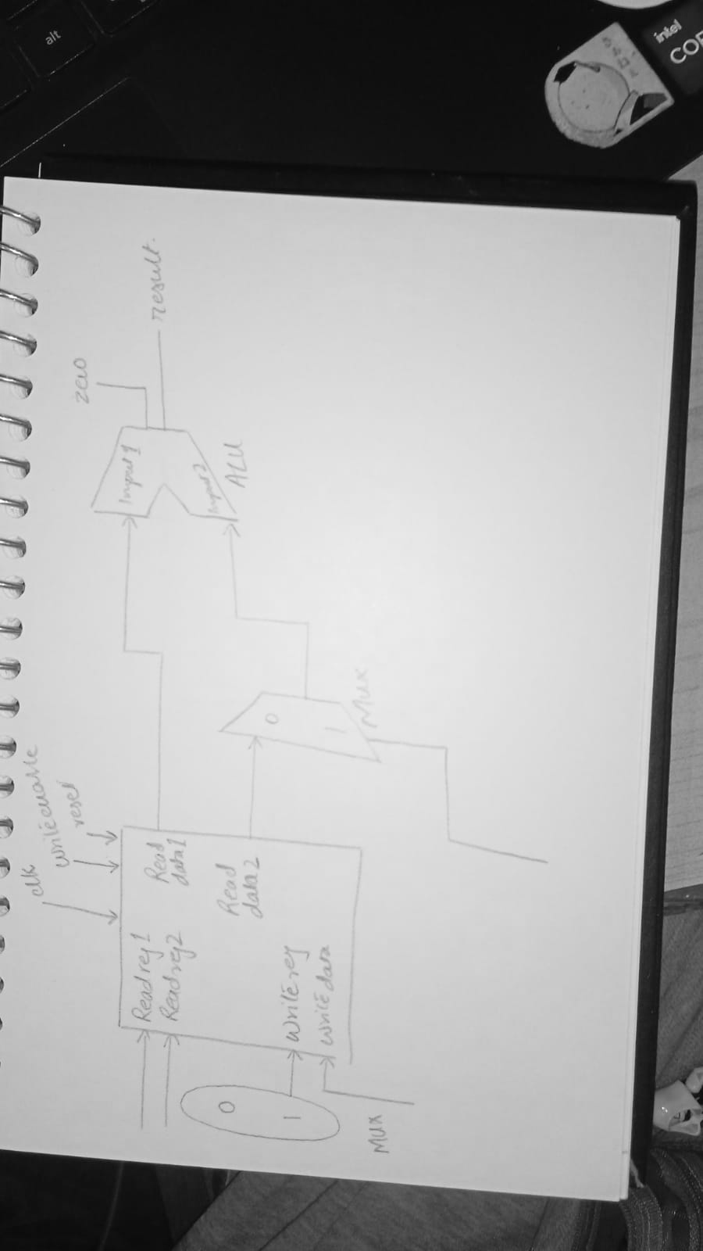

Comments

Task 2

Modules + Testbench:
RegisterFile
`timescale 1ns / 1ps
//////////////////////////////////////////////////////////////////////////////////
// Company:
// Engineer:
//
// Create Date: 03/05/2026 09:08:32 AM
// Design Name:
// Module Name: RegisterFile
// Project Name:
// Target Devices:
// Tool Versions:
// Description:
//
// Dependencies:
//
// Revision:
// Revision 0.01 - File Created
// Additional Comments:
//
//////////////////////////////////////////////////////////////////////////////////

module RegisterFile(
input clk, rst, WriteEnable,
input [4:0] rs1, rs2, rd,
input [31:0] WriteData,
output [31:0] readData1, readData2
);

reg[31:0] regs [31:0];
initial begin
regs[0] = 32'h00000000;
regs[1] = 32'h10101010;
regs[2] = 32'h01010101;
end

always @ (posedge clk) begin
if (WriteEnable == 1 && rd != 5'b0) regs[rd] <= WriteData;
end

assign readData1=regs[rs1];
assign readData2=regs[rs2];

endmodule

register file testbench
`timescale 1ns / 1ps

module RegisterFile_tb;

reg clk;
reg reset;
reg WriteEnable;
reg [4:0] rs1;
reg [4:0] rs2;
reg [4:0] rd;
reg [31:0] WriteData;
wire [31:0] readData1;
wire [31:0] readData2;

// Instantiate DUT (Device Under Test)
RegisterFile uut (
.clk(clk),
.reset(reset),
.WriteEnable(WriteEnable),
.rs1(rs1),
.rs2(rs2),
.rd(rd),
.WriteData(WriteData),
.readData1(readData1),
.readData2(readData2)
);

always #5 clk = ~clk;
initial begin

$display("Starting Register File Testbench");
//test1
clk = 0;
reset = 1;
WriteEnable = 0;
rs1 = 0;
rs2 = 0;
rd = 0;
WriteData = 0;
#10;
reset = 0;
rs1 = 5;
#10;
$display("After reset, x5 = %h (should be 0)", readData1);
//test2
rd = 5;
WriteData = 32'hDEADBEEF;
WriteEnable = 1;
#10;
WriteEnable = 0;
rs1 = 5;
#10;

$display("Write x5 = %h (expect DEADBEEF)", readData1);

//test3
rd = 0;
WriteData = 32'hFFFFFFFF;
WriteEnable = 1;
#10;
WriteEnable = 0;
rs1 = 0;
#10;
$display("x0 after write attempt = %h (should be 0)", readData1);

//test4
rd = 6;
WriteData = 32'h12345678;
WriteEnable = 1;
#10;

WriteEnable = 0;

rs1 = 5;
rs2 = 6;
#10;

$display("Read rs1(x5) = %h (expect DEADBEEF)", readData1);
$display("Read rs2(x6) = %h (expect 12345678)", readData2);

//test5
rd = 5;
WriteData = 32'hAAAAAAAA;
WriteEnable = 1;
#10;
WriteEnable = 0;
rs1 = 5;
#10;
$display("Overwrite x5 = %h (expect AAAAAAAA)", readData1);
#20;
$display("Testbench complete.");
$finish;

end

endmodule

ALU
`timescale 1ns / 1ps
//////////////////////////////////////////////////////////////////////////////////
// Company:
// Engineer:
//
// Create Date: 02/26/2026 09:43:45 AM
// Design Name:
// Module Name: ALU_module
// Project Name:
// Target Devices:
// Tool Versions:
// Description:
//
// Dependencies:
//
// Revision:
// Revision 0.01 - File Created
// Additional Comments:
//
//////////////////////////////////////////////////////////////////////////////////

module ALU(
input [31:0]A, input [31:0]B,
input [3:0] ALUControl,
output reg [31:0]ALUResult,
output zero
);

always @(*) begin
if (ALUControl == 4'b0000) ALUResult <= A+B;
else if (ALUControl == 4'b0001) ALUResult <= A-B;
else if (ALUControl == 4'b0010) ALUResult <= A&B;
else if (ALUControl == 4'b0011) ALUResult <= A|B;
else if (ALUControl == 4'b0100) ALUResult <= A^B;
else if (ALUControl == 4'b0101) ALUResult <= A<<B[4:0];
else if (ALUControl == 4'b0110) ALUResult <= A>>B[4:0];
else ALUResult <= 32'b0;

end

assign zero = (ALUResult==0);

endmodule

RF ALU FSM Testbench
`timescale 1ns/1ps

module RF_ALU_FSM_tb;

reg clk;
reg rst;

reg WriteEnable;
reg [4:0] rs1, rs2, rd;
reg [31:0] WriteData;
reg [3:0] ALUControl;

wire [31:0] ReadData1;
wire [31:0] ReadData2;
wire [31:0] ALUResult;
wire Zero;

/////////////////////////////////////
// Instantiate Register File
/////////////////////////////////////

RegisterFile RF_inst(
.clk(clk),
.reset(rst),
.WriteEnable(WriteEnable),
.rs1(rs1),
.rs2(rs2),
.rd(rd),
.WriteData(WriteData),
.readData1(ReadData1),
.readData2(ReadData2)
);

/////////////////////////////////////
// Instantiate ALU
/////////////////////////////////////

ALU_module ALU_inst(
.A(ReadData1),
.B(ReadData2),
.ALUControl(ALUControl),
.ALUResult(ALUResult),
.zero(Zero)
);

/////////////////////////////////////
// FSM Variables
/////////////////////////////////////

reg [2:0] current_state;
reg [2:0] alu_step;
reg [1:0] write_count;

parameter START = 3'd0;
parameter INIT_WRITE = 3'd1;
parameter FETCH_REGS = 3'd2;
parameter EXECUTE_ALU = 3'd3;
parameter STORE_RES = 3'd4;

/////////////////////////////////////
// Clock generation
/////////////////////////////////////

always #5 clk = ~clk;

/////////////////////////////////////
// FSM Logic
/////////////////////////////////////

always @(posedge clk or posedge rst)
begin

if(rst)
begin
current_state <= START;
alu_step <= 0;
write_count <= 0;
end

else
begin

case(current_state)

////////////////////////////////////////////////
// Idle state
////////////////////////////////////////////////

START:
begin
WriteEnable <= 0;
current_state <= INIT_WRITE;
end

////////////////////////////////////////////////
// Initialize registers
////////////////////////////////////////////////

INIT_WRITE:
begin
WriteEnable <= 1;

case(write_count)

2'd0:
begin
rd <= 5'd1;
WriteData <= 32'hAAAA0000;
end

2'd1:
begin
rd <= 5'd2;
WriteData <= 32'h0000BBBB;
end

2'd2:
begin
rd <= 5'd3;
WriteData <= 32'h00000008;
end

endcase

if(write_count == 2'd2)
begin
WriteEnable <= 1;
current_state <= FETCH_REGS;
end
else
write_count <= write_count + 1;

end

////////////////////////////////////////////////
// Select registers for ALU
////////////////////////////////////////////////

FETCH_REGS:
begin
rs1 <= 5'd1;
rs2 <= 5'd2;
current_state <= EXECUTE_ALU;
end

////////////////////////////////////////////////
// Choose ALU operation
////////////////////////////////////////////////

EXECUTE_ALU:
begin

case(alu_step)

3'd0: ALUControl <= 4'b0000; // ADD
3'd1: ALUControl <= 4'b0001; // SUB
3'd2: ALUControl <= 4'b0010; // AND
3'd3: ALUControl <= 4'b0011; // OR
3'd4: ALUControl <= 4'b0100; // XOR
3'd5: ALUControl <= 4'b0101; // SLL
3'd6: ALUControl <= 4'b0110; // SRL

endcase

current_state <= STORE_RES;

end

////////////////////////////////////////////////
// Save ALU result
////////////////////////////////////////////////

STORE_RES:
begin

WriteEnable <= 1;
rd <= 5'd6 + alu_step;
WriteData <= ALUResult;

WriteEnable <= 1;

if(alu_step == 3'd6)
begin

// BEQ-style check
rs1 <= 5'd1;
rs2 <= 5'd1;
ALUControl <= 4'b0001;

if(Zero)
begin
rd <= 5'd15;
WriteEnable <= 1;
WriteData <= 32'h00000001;
end

$finish;

end

else
begin
alu_step <= alu_step + 1;
current_state <= FETCH_REGS;
end

end

endcase
end
end

/////////////////////////////////////
// Initial block
/////////////////////////////////////

initial
begin

clk = 0;
rst = 1;

WriteEnable = 1;
rs1 = 0;
rs2 = 0;
rd = 0;
WriteData = 0;
ALUControl = 0;

#12 rst = 0;

end

endmodule

Results:

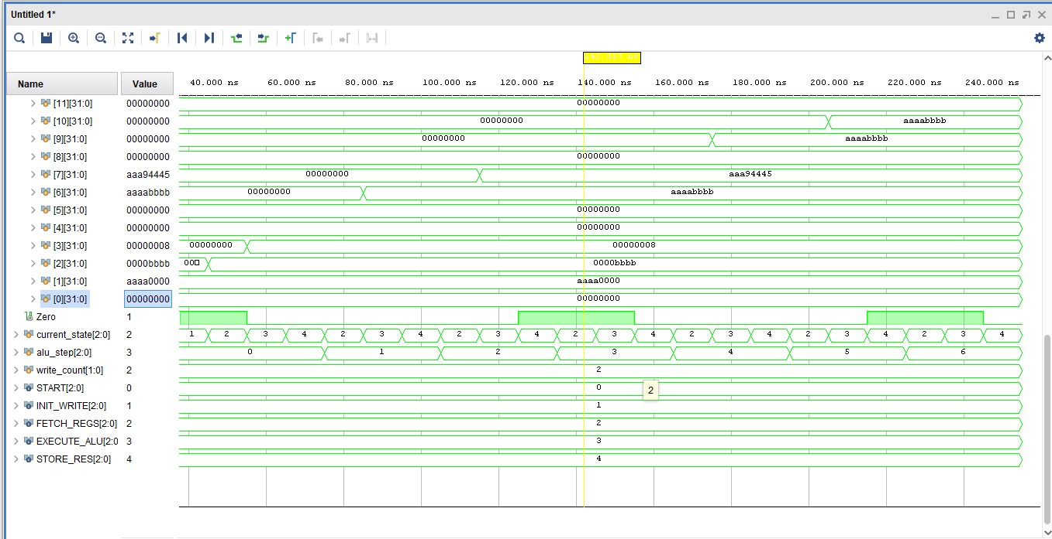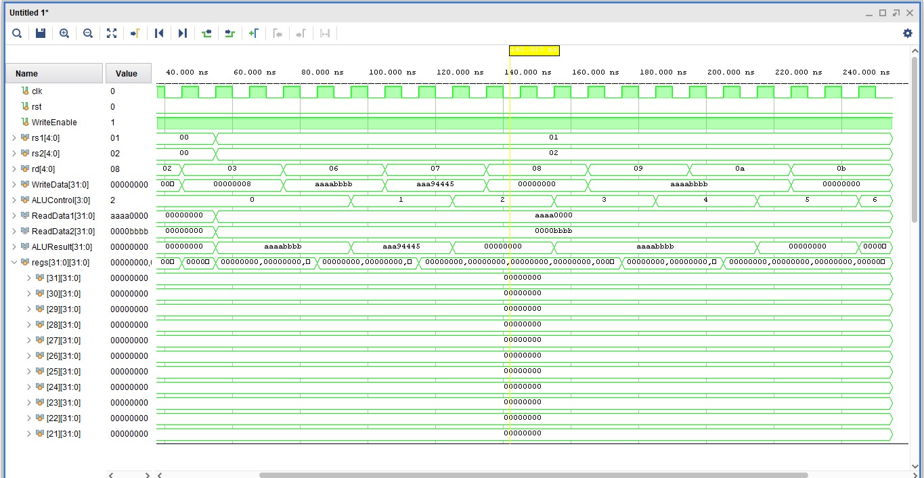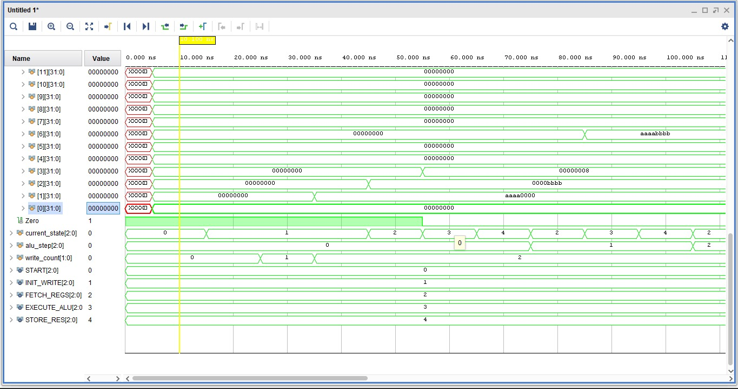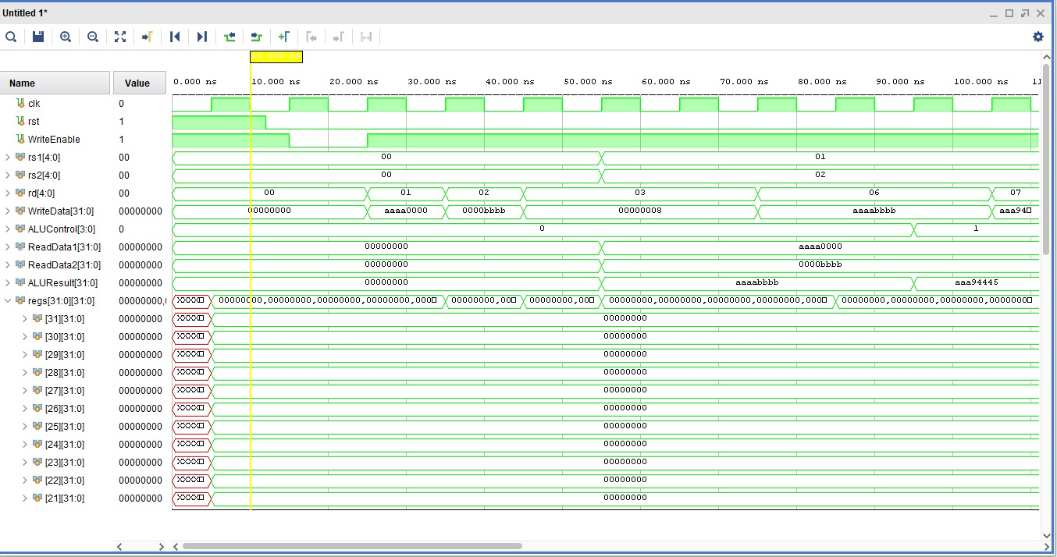

Task 3

RTL Schematics

Top module
`timescale 1ns / 1ps

module top_rf_alu (
input wire clk,
input wire [15:0] SW,
input wire [4:0] BTN,
output wire [15:0] LED
);

wire rst;

debounce db_inst (
.clk (clk),
.pbin (BTN[0] | SW[15]),
.pbout(rst)
);

wire [31:0] sw_data;

switches sw_inst (
.clk (clk),
.rst (rst),
.btns ({11'b0, BTN}),
.switches (SW),
.readEnable (1'b1),
.writeData (32'b0),
.writeEnable(1'b0),
.readData (sw_data)
);

reg rf_we;
reg [4:0] rf_rs1;
reg [4:0] rf_rs2;
reg [4:0] rf_rd;
reg [31:0] rf_wdata;

wire [31:0] rf_out1;
wire [31:0] rf_out2;

RegisterFile RF_inst (
.clk (clk),
.reset (rst),
.WriteEnable(rf_we),
.rs1 (rf_rs1),
.rs2 (rf_rs2),
.rd (rf_rd),
.WriteData (rf_wdata),
.readData1 (rf_out1),
.readData2 (rf_out2)
);
reg [3:0] alu_ctrl;
wire [31:0] alu_res;
wire alu_zero;

ALU_module ALU_inst (
.A (rf_out1),
.B (rf_out2),
.ALUControl(alu_ctrl),
.ALUResult (alu_res),
.zero (alu_zero)
);

reg [31:0] led_din;
wire [31:0] led_dout;
wire [15:0] led_out;

assign led_out = led_dout[15:0];
assign LED = led_out;

leds led_inst (
.clk (clk),
.rst (rst),
.btns ({11'b0, BTN}),
.writeData (led_din),
.writeEnable(1'b1),
.readEnable (1'b1),
.memAddress (30'b0),
.switches (SW),
.readData (led_dout)
);

localparam [2:0]
S_RESET = 3'd0,
S_WRITE_A = 3'd1,
S_WRITE_B = 3'd2,
S_FETCH = 3'd3,
S_EXECUTE = 3'd4,
S_STORE = 3'd5,
S_BEQ = 3'd6,
S_IDLE = 3'd7;

localparam [31:0] CONST_A = 32'h10101010;
localparam [31:0] CONST_B = 32'h01010101;

reg [2:0] state;
reg [2:0] op_idx;

reg [28:0] tick_cnt;
reg tick;

always @(posedge clk) begin
if (rst) begin
tick_cnt <= 29'd0;
tick <= 1'b0;
end else begin
tick <= 1'b0;
if (tick_cnt == 29'd299_999_999) begin // 3 seconds at 100 MHz
tick_cnt <= 29'd0;
tick <= 1'b1;
end else begin
tick_cnt <= tick_cnt + 1;
end
end
end

always @(posedge clk) begin
if (rst) begin
state <= S_RESET;
op_idx <= 3'd0;
rf_we <= 1'b0;
rf_rs1 <= 5'd0;
rf_rs2 <= 5'd0;
rf_rd <= 5'd0;
rf_wdata <= 32'd0;
alu_ctrl <= 4'b0000;
end
else if (tick) begin
rf_we <= 1'b0;

case (state)

S_RESET: begin
op_idx <= 3'd0;
state <= S_WRITE_A;
end

// write x1 = 0x10101010
S_WRITE_A: begin
rf_we <= 1'b1;
rf_rd <= 5'd1;
rf_wdata <= CONST_A;
state <= S_WRITE_B;
end

// write x2 = 0x01010101
S_WRITE_B: begin
rf_we <= 1'b1;
rf_rd <= 5'd2;
rf_wdata <= CONST_B;
state <= S_FETCH;
end

S_FETCH: begin
rf_rs1 <= 5'd1;
rf_rs2 <= 5'd2;
state <= S_EXECUTE;
end

S_EXECUTE: begin
case (op_idx)
3'd0: alu_ctrl <= 4'b0000; // ADD
3'd1: alu_ctrl <= 4'b0001; // SUB
3'd2: alu_ctrl <= 4'b0010; // AND
3'd3: alu_ctrl <= 4'b0011; // OR
3'd4: alu_ctrl <= 4'b0100; // XOR
3'd5: alu_ctrl <= 4'b0101; // SLL
3'd6: alu_ctrl <= 4'b0110; // SRL
default: alu_ctrl <= 4'b0000;
endcase
state <= S_STORE;
end

S_STORE: begin
rf_we <= 1'b1;
rf_rd <= 5'd4 + {2'b00, op_idx};
rf_wdata <= alu_res;

if (op_idx == 3'd6) begin
state <= S_BEQ;
end else begin
op_idx <= op_idx + 1;
state <= S_FETCH;
end
end

S_BEQ: begin
rf_rs1 <= 5'd1;
rf_rs2 <= 5'd1;
alu_ctrl <= 4'b0001; // SUB
state <= S_IDLE;
end

S_IDLE: begin
rf_rs1 <= 5'd1;
rf_rs2 <= 5'd2;
alu_ctrl <= {1'b0, sw_data[2:0]};
rf_we <= sw_data[3];
state <= S_RESET;
end

default: state <= S_RESET;

endcase
end
end

always @(*) begin
led_din = {
16'b0,
alu_res[8:0], // LED[15:7] result
alu_zero, //zero -led6
op_idx, // LED[5:3] operation
state // LED[2:0] fsm
};
end

endmodule

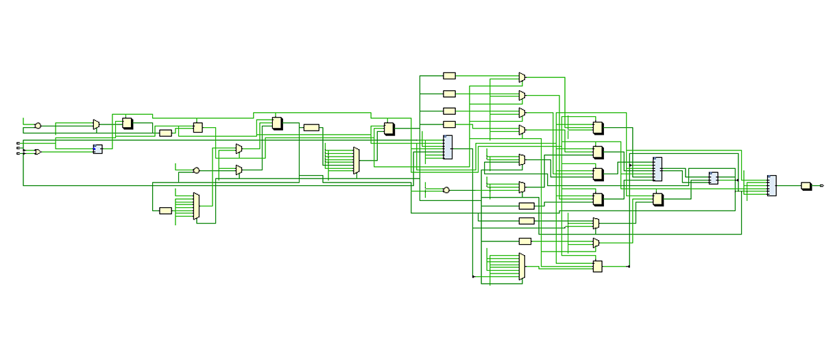

Add

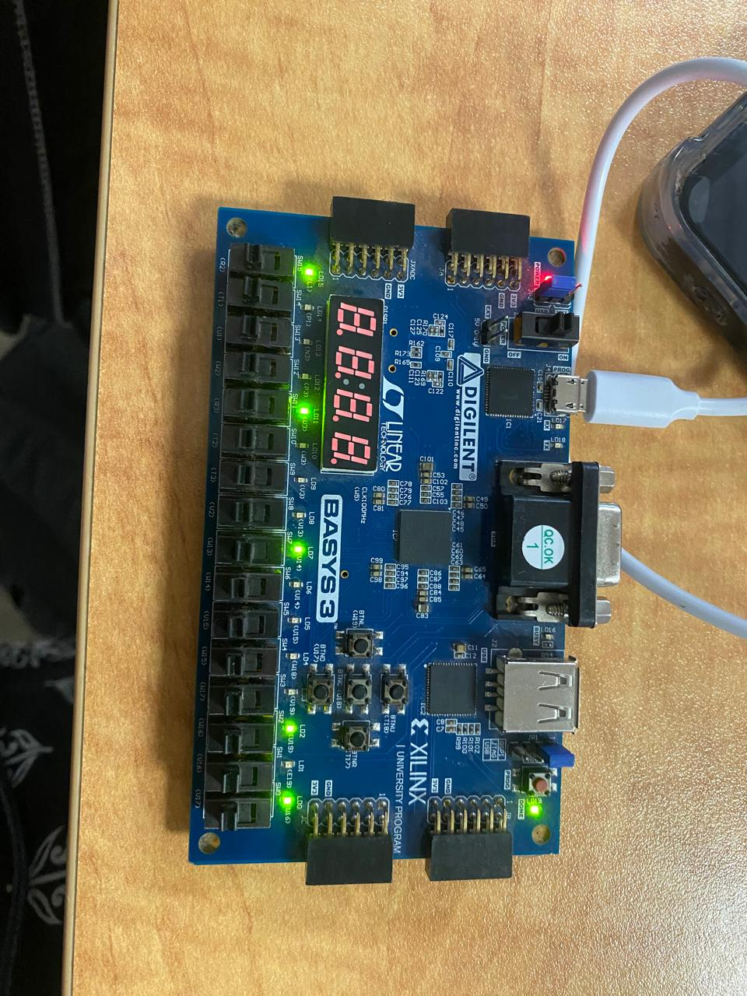

Sub

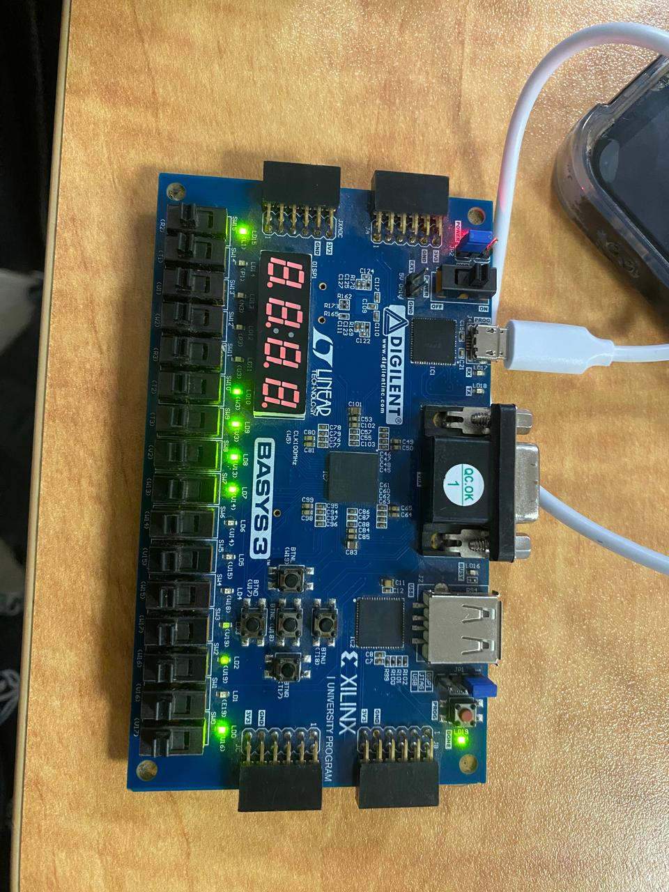

And

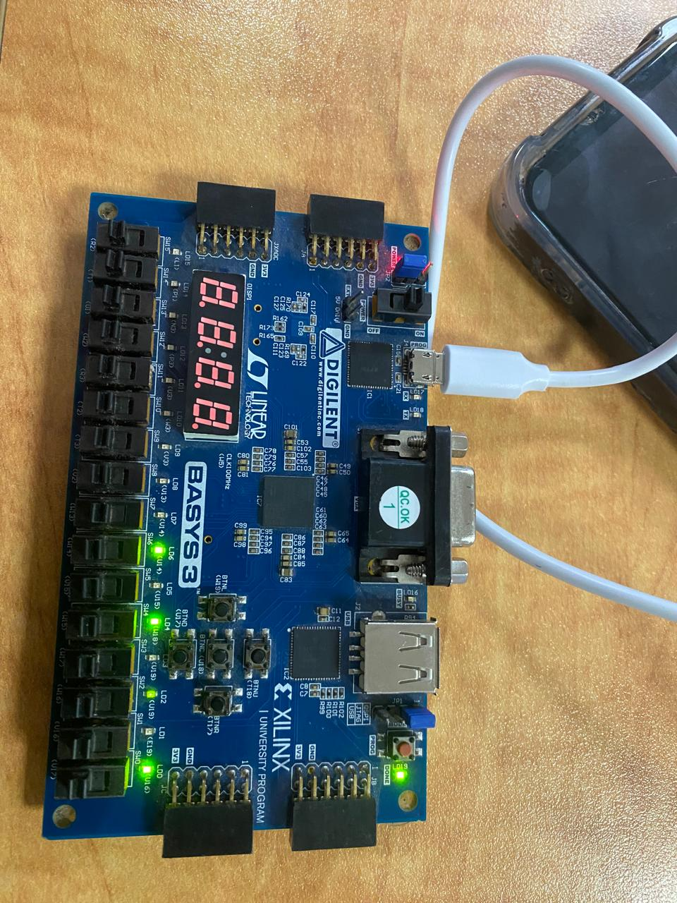

Or
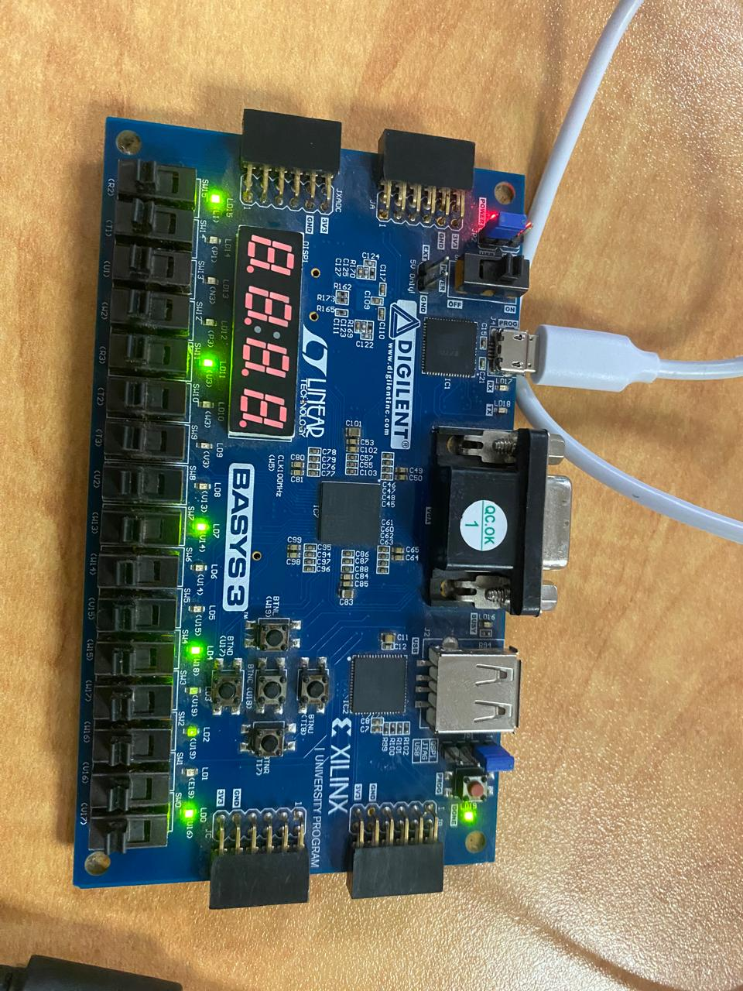

Xor

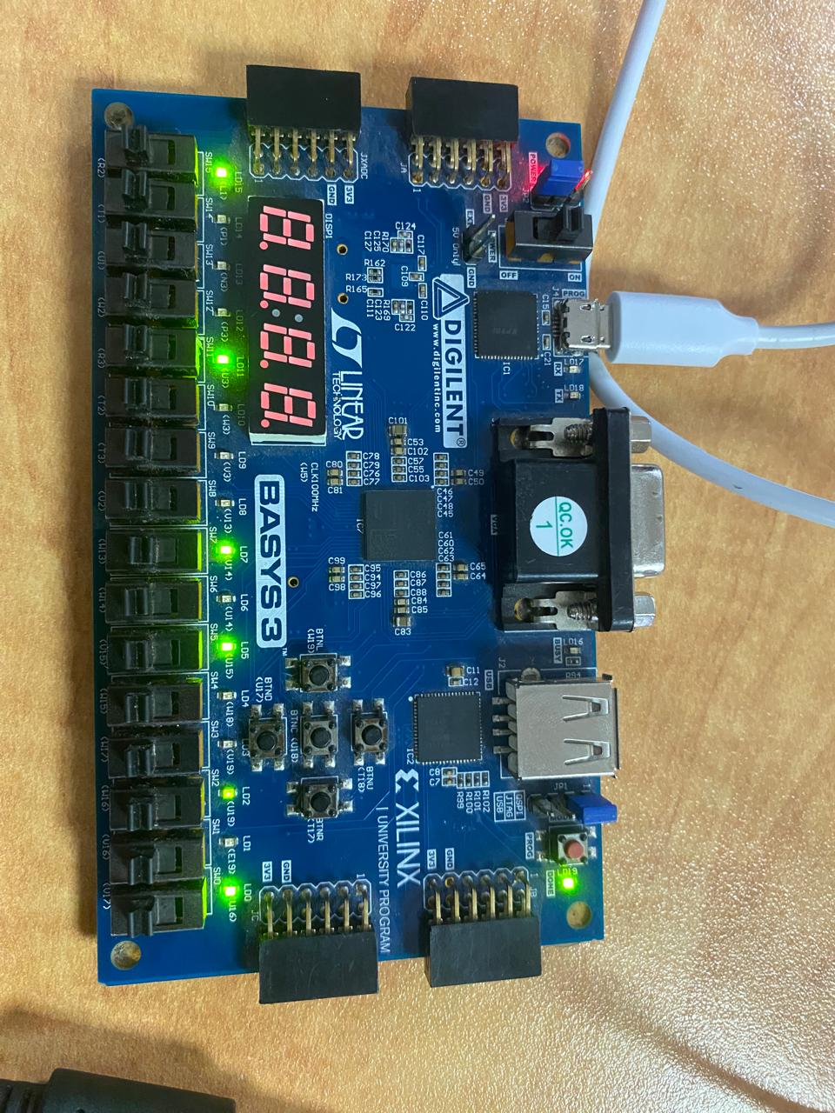

Sll

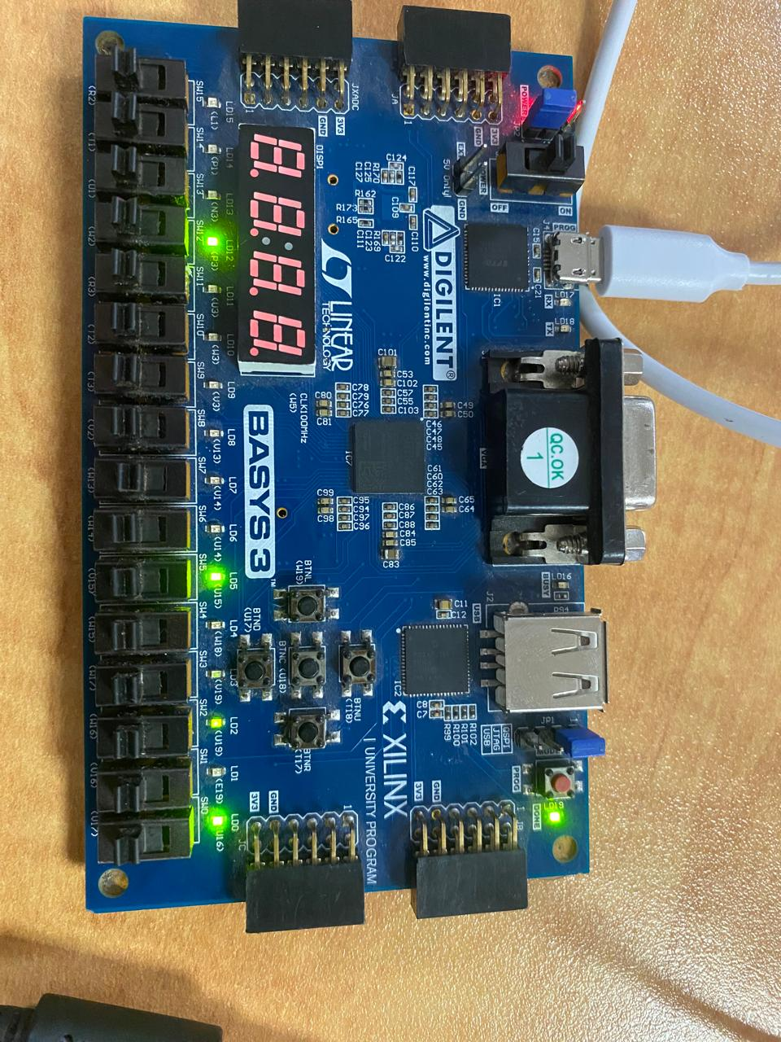

Srl

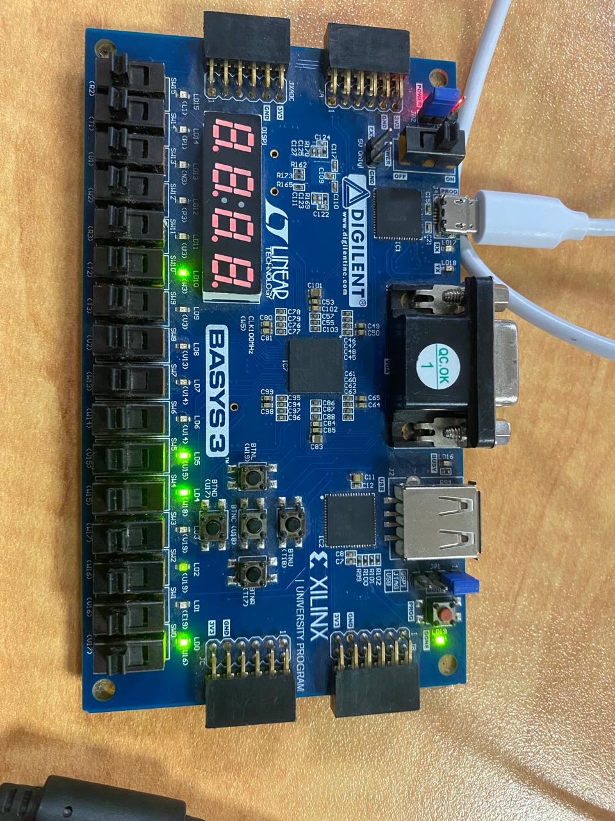

Beq

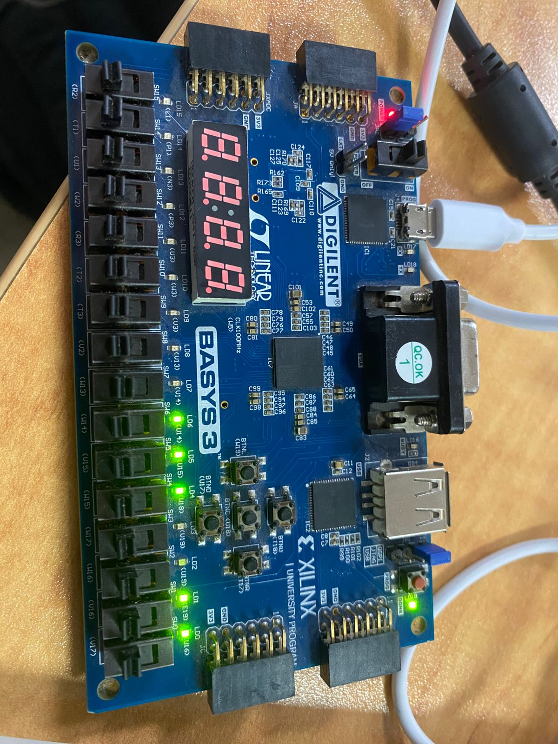

Lab 07

Points Distribution
Task No. | LR2  Code | LR 5  Results | LR11  Design | AR7
Task 1 | - | - | /20 | /20
Task 2 | /20 | /15
Task 3 | /10 | /15
Total Points | /80 |  |  | /20
CLO Mapped | CLO 1
For description of different levels of the mapped rubrics, please refer the provided Lab Evaluation Assessment Rubrics and Affective Domain Assessment Rubrics.
# | Assessment Elements | Level 1: Unsatisfactory  Points 0-1 | Level 2: Developing  Points 2 | Level 3:Good  Points 3 | Level 4:Exemplary  Points 4
LR2 | Program/Code/ Simulation Model/ Network Model | Program/code/simulation model/network model does not implement the required functionality and has several errors. The student is not able to utilize even the basic tools of the software. | Program/code/simulation model/network model has some errors and does not produce completely accurate results. Student has limited command on the basic tools of the software. | Program/code/simulation model/network model gives correct output but not efficiently implemented or implemented by computationally complex routine. | Program/code/simulation /network model is efficiently implemented and gives correct output. Student has full command on the basic tools of the software.
LR5 | Results & Plots | Figures/ graphs / tables are not developed or are poorly constructed with erroneous results. Titles, captions, units are not mentioned. Data is presented in an obscure manner. | Figures, graphs and tables are drawn but contain errors. Titles, captions, units are not accurate. Data presentation is not too clear. | All figures, graphs, tables are correctly drawn but contain minor errors or some of the details are missing. | Figures / graphs / tables are correctly drawn and appropriate titles/captions and proper units are mentioned. Data presentation is systematic.
AR9 | Report | All the in-lab tasks are not included in report and / or the report is submitted too late. | Most of the tasks are included in report but are not well explained. All the necessary figures / plots are not included. Report is submitted after due date. | Good summary of most the in-lab tasks is included in report. The work is supported by figures and plots with explanations. The report is submitted timely. | Detailed summary of the in-lab tasks is provided. All tasks are included and explained well. Data is presented clearly including all the necessary figures, plots and tables.

